Student Name and Number: Cathy (Yuchun) Feng, 1007129144 PRA Group: ___
Student Name and Number: Mengshu Li, 1007098533
THE OUTPUT RESISTANCE OF A POWER SUPPLY
Working with your partner, answer the questions in this exercise and submit them as a single file (including tables, figures, etc.) via Quercus by 11:59 on the Tuesday following your session. This is not as formal as Lab 1 and Lab 2 which you will do later in the term but make sure that your submission contains the title, both of your names, and the date.
Objectives: to review basic electrical measurement techniques; analyze uncertainties of direct and indirect measurements; understand error propagation; apply curve fitting to the set of data points; calculate uncertainty in linear fit.
I. Introduction
Any source of electrical energy (generator, battery, thermocouple, etc.) with no load attached to it produces voltage potential across the terminals called an electromotive force (emf), or an open-circuit voltage, $V_{∞}$.
This number does not completely specify the power supply. In a closed circuit, a current I will be drawn from the power supply, and the voltage at the terminals, $V$, called the terminal voltage, will typically fall below $V_{∞}$. A plot of what the terminal voltage $V$ vs. current $I$ may look like is shown in Fig. 1.
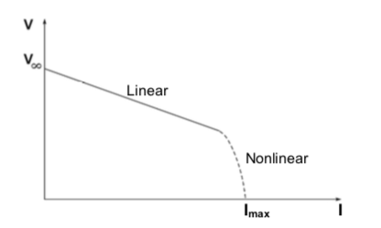
FIG.1: Terminal voltage vs. current
Many power sources will exhibit a linear variation of V for small current values, followed by a nonlinear behaviour at higher currents. The linear part of the curve can be described by
$V=V_{∞}-RI,$ (1)
where $R$ is the output resistance of the power source. In this linear regime, according to Thevenin’s theorem, the power source is completely represented by this equivalent circuit as in Fig. 2.
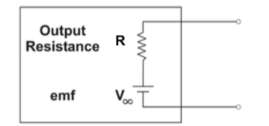
Fig. 2. Equivalent circuit of an electric power source.
The output resistance ($R$) can be determined by attaching different external resistances of the load ($R_{l}$) to the power source, and measuring the current and voltage with a multimeter. Figure 3 shows two possible ways of doing this. Both would be equivalent if the multimeter were ideal. However, in this exercise we will measure with real, not ideal, multimeters.
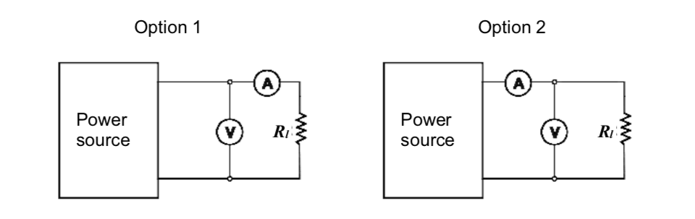
Fig. 3. Possible circuits for determining the output resistance of a power source.
Setup
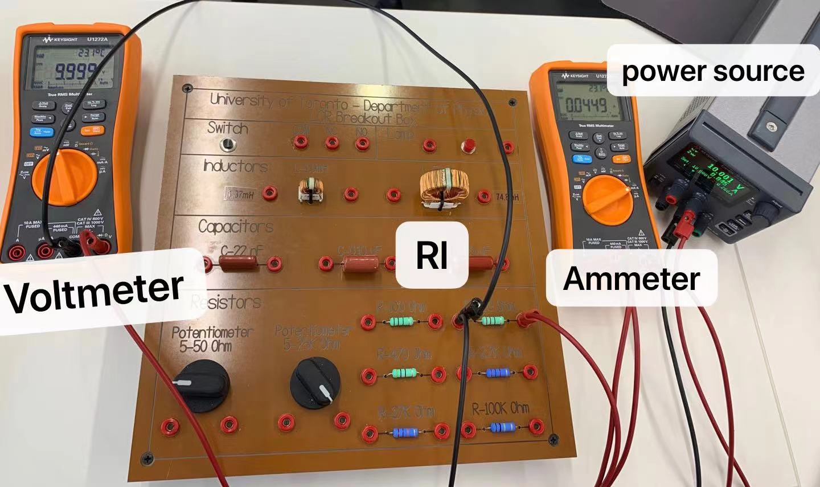
Figure. Setup of the Lab
Question 1:
Without connecting circuits and making measurements, how would you expect the readings of the voltmeter and the ammeter to differ between Option 1 and in Option 2? Explain.
The ammeter in Option 1 measures the current going through resistor $R_{l}$, whereas the ammeter in Option 2 measures the current coming out of the power source, which is the sum of current going through resistor ($R_{l}$) and current going through the voltmeter (assuming the voltmeter is not ideal). The voltmeter in Option 1 measures the voltage across the ammeter (assuming the ammeter is not ideal) and resistor $R_{l}$, while the voltmeter in Option 2 measures the voltage across resistor $R_{l}$ alone. Thus, the measurement of voltmeter in Option 1 is predicted to be larger than that of Option 2, while the measurement of ammeter in Option 1 is predicted to be smaller than that of Option 2.
Question 2:
To calculate the resistance of the power source, you will need to know the internal resistance of the voltmeter and the ammeter. How can you find these values by making measurements of current and voltage with the Option 1 and Option 2 circuits? Derive the general formulae for the internal resistance of the voltmeter and the ammeter based on the results of these measurements and the known resistance of the load.
Finding the resistance of the ammeter ($R_{A}$) with Option 1:
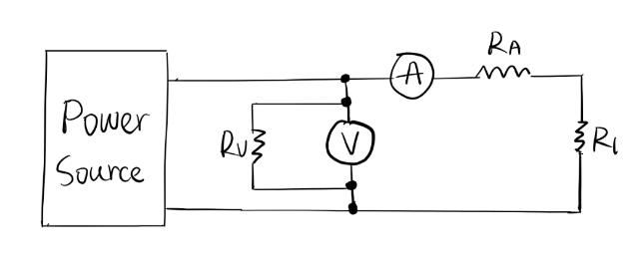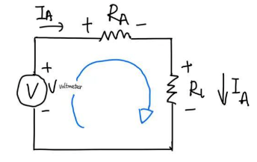
Apply Kirchhoff's Voltage Law, we get
$V_{voltmeter}=I_{A}*R_{A}+I_{A}*R_{l}=0$.
Re-arranging gives
$$R_{A}=\frac{V_{voltmeter}}{I_{A}}-R_{l}$$
Finding the resistance of the voltmeter ($R_{V}$) with Option 2:
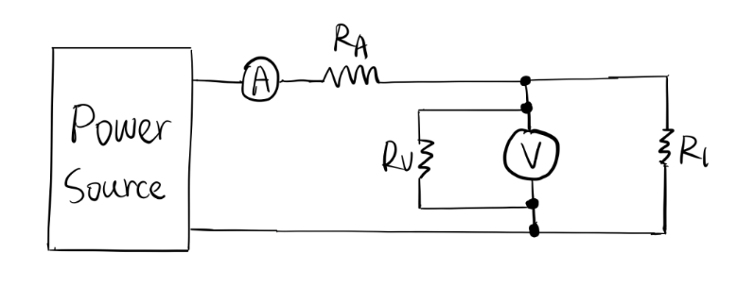
Apply Kirchhoff's Current Law, we get
${I_{A}= I}_{V}+I_{R}$.
Applying Kirchhoff's Voltage Law and Ohm’s Law on $R_{l}$, we get
$V_{voltmeter}=V_{R_{l}}= R_{l}*I_{R}$.
Re-arranging gives
$$I_{A}=\frac{V_{voltmeter}}{R_{v}}+\frac{V_{voltmeter}}{R_{l}}$$
$R_{V}={\left(\frac{I_{A}}{V_{voltmeter}}-\frac{1}{R_{l}}\right)}^{-1}$

II. The Experiment
Measure the resistance of 7 resistors with the multimeter set to ohmmeter. Use the data to complete the table below and indicate the (reading) uncertainty for each measurement.
Table 1
$$R_{l1}$$  $$Ω$$ | $${ΔR}_{l1}$$  $$Ω$$ | $$R_{l2}$$  $$Ω$$ | $${ΔR}_{l2}$$  $$Ω$$ | $$R_{l3}$$  $$Ω$$ | $${ΔR}_{l3}$$  $$Ω$$ | $$R_{l4}$$  $$Ω$$ | $${ΔR}_{l4}$$  $$Ω$$ | $$R_{l5}$$  $$Ω$$ | $${ΔR}_{l5}$$  $$Ω$$ | $$R_{l6}$$  $$Ω$$ | $${ΔR}_{l6}$$  $$Ω$$
104.1 | ±0.01 | 220.3 | ±0.01 | 464.5 | ±0.01 | 2691.0 | ±0.01 | 27090.1 | ±0.01 | 98950.0 | ±0.01

Question 3:
Choose at least 4 of these resistors to construct circuits for this experiment. Briefly justify your choice.
For option one, since we aim to simulate the resistance of ammeter which has a relatively small value and ideally considered as a short circuit, we chose four small resistors (100Ω, 220Ω, 470Ω, and 2700Ω). For option two, we used four large resistors (470Ω, 2700Ω,27000Ω, and 100000Ω) to simulate the resistance of voltmeter, which is a very large and ideally considered as an open circuit.

Circuit Option 1:
- Assemble circuit Option 1 (Fig. 3). Sketch or photograph it and include this sketch/photograph in your report. List the elements of the circuit in a caption.
- If you are working with a DC power supply, set it to about 6.5V.
- Measure the voltage $V$ and current $I$ for circuits with your four chosen resistors. You can use more than 4 resistors if you like. Use this information to calculate the internal resistance of the ammeter. Organize all of the data in Table 2.
Table 2. For Circuit Option 1
 | Resistance  $$R_{li},Ω$$ | Uncertainty  ${ΔR}_{li},Ω$* | Voltage $V,$V | Uncertainty  $ΔV,$V* | Current  $I$, mA | Uncertainty  $ΔI$, mA* | Resistance of ammeter  $$R_{A},Ω$$ | Uncertainty  ${ΔR}_{A},Ω$**
1 | 104.1 | ±0.01 | 6.498 | ±0.001 | 64.510 | ±0.005 | -3.371 | 0.0200
2 | 220.3 | ±0.01 | 6.499 | ±0.001 | 29.268 | ±0.005 | 1.751 | 0.0520
3 | 464.5 | ±0.01 | 6.500 | ±0.001 | 13.944 | ±0.005 | 1.650 | 0.1822
4 | 2691.0 | ±0.01 | 6.501 | ±0.001 | 2.414 | ±0.005 | 2.041 | 5.5933
 |  |  |  |  |  | Average: | 0.5178 | 1.4619
*The uncertainty of $R_{li}$, V and I are determined by taking the mean value of fluctuating reading on the multimeter. For example, we had 104.09 $Ω$, 104.10 $Ω$ and 104.11 $Ω$ when measuring the resistance of the first resistor, we took its uncertainty as (104.11-104.09)/2 $Ω$. Similarly, we observe the reading uncertainty of voltage and current. Since our observation, ±0.001 and ±0.005 are larger than the theoretical reading uncertainty of digital meter (±1/2 of last digit), we take the observed uncertainty to be our measurement uncertainty. Same for option 2.
**To find the uncertainty of $R_{A}$, take the partial derivative of the formula derived from Question 2:
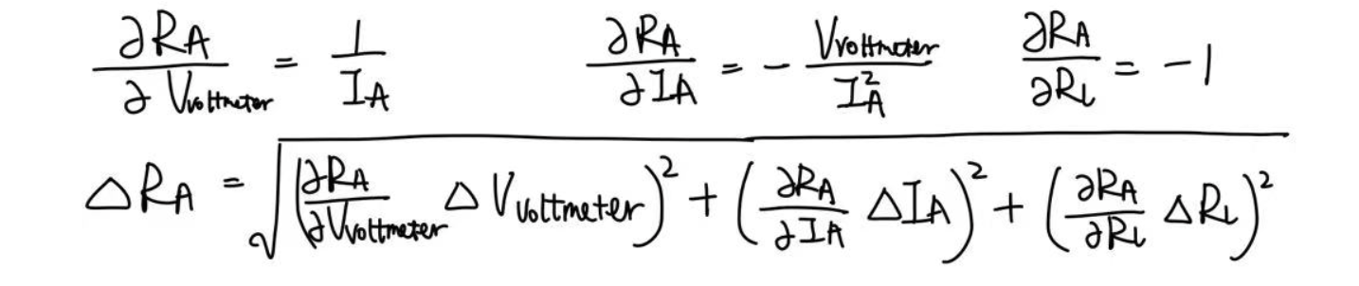
- Plot $V$ vs $I$ and apply a linear fit to determine the slope $m_{1}$ and its uncertainty. Check two goodness of fit criteria.

Value of $m_{1}$, $b_{1}$, $s_{m}$ , and $s_{b}$:
- The value of the slope $m_{1}$ is -0.04612, representing the estimated average of R.
- The value of y-intercept b is 6.5008, which represents that the initial voltage of the circuit is 6.5008V.
- $s_{m}$ is 0.00896, the standard deviation of estimated slope m, meaning that there’s 0.00896 dispersion among all estimated values of $m_{1}$ to its mean value.
- $s_{b}$ is 0.000324, the standard deviation of the y-intercept of the line, meaning that there’s 0.000324 dispersion among all estimated values of $b_{1}$ to its mean value.
LINEST y- dimension's error bars s(y) in the y-values:
s(y) = 0.000419, which represents the standard error for y-values estimated in the best fit line, meaning that there’s 0.000419 dispersion among all estimated values of y to its mean value at each point.
Pearson’s Chi-squared Goodness of Fit Test:
The chi-squared criterion of the goodness of fit is first used to evaluate the quality of the best fit, given by:
$χ^{2}=\sum_{i=1}^{n}{\frac{{\left(O_{i}-E_{i}\right)}^{2}}{E_{i}}}$,
where $O_{i}=observed count$, $E_{i}=expected count$, and $n=number of data points$. The excel function CHISQ.TEST returns the goodness of the expected count value predicting the observed count value. With this function, the Chi-Squared Value for Option 1 is around 1, indicating that the fitting function is a good approximation to the parent data.
R-Squared Test:
The R-Squared value is a statistical measurement of how close the actual data are to the fitted curve. The higher the R-Square value, the better the prediction model. R Square of the linear fitting function is around 0.9297, meaning that the data points are relatively close to the fitted linear regression line.

Circuit Option 2:
- Assemble circuit Option 2 (Fig. 3).
- Measure the voltage $V$ and current $I$ for circuits with your four (or more) chosen resistors. Use this information to calculate the internal resistance of the voltmeter. Organize all of the data in Table 2.
Table 3. For Circuit Option 2
 | Resistance  $$R_{li},Ω$$ | Uncertainty  ${ΔR}_{li},Ω$* | Voltage $V,$V | Uncertainty  $ΔV,$V* | Current  $I$, mA | Uncertainty  $ΔI$, mA* | Resistance of voltmeter  $$R_{V},Ω$$ | Uncertainty  ${ΔR}_{V},Ω$**
1 | 464.5 | ±0.01 | 6.476 | ±0.001 | 13.946 | ±0.005 | 1569171.6 | 2374559.74
2 | 2691.0 | ±0.01 | 6.497 | ±0.001 | 2.414 | ±0.005 | -18880590.7 | 61265226729.00
3 | 27090.1 | ±0.01 | 6.501 | ±0.001 | 0.240 | ±0.005 | 282231955.3 | 275096339.20
4 | 98950.0 | ±0.01 | 6.501 | ±0.001 | 0.0620 | ±0.005 | -1757099.0 | 2073070.29
 |  |  |  |  |  | Average: | 65790859.3 | 15386192674.00
*The uncertainty of $R_{li}$, V and I are determined in the same way as option 1.
**To find the uncertainty of $R_{V}$, take the partial derivative of the formula derived from Question 2:
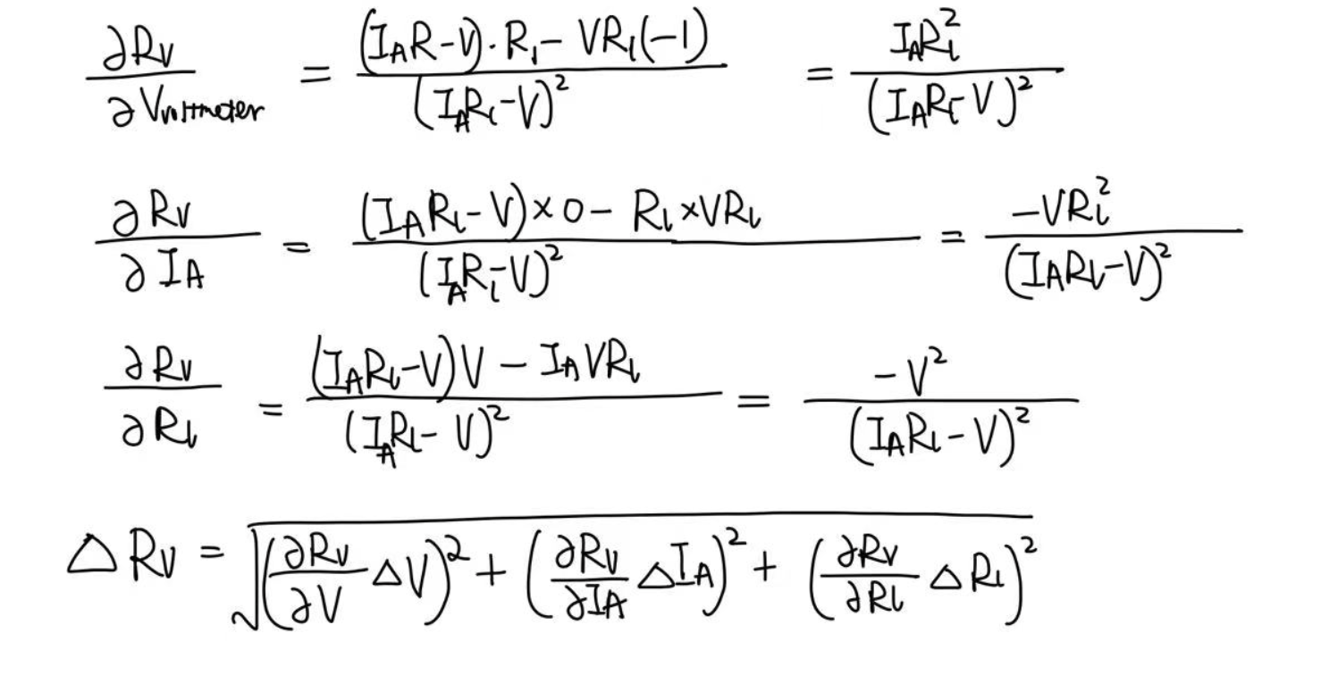
- Plot $V$ vs $I$ and apply a linear fit to determine the slope $m_{2}$ and its uncertainty. Check two goodness of fit criteria.

Value of $m_{2}$, $b_{2}$, $s_{m}$ , and $s_{b}$:
- The value of the slope m is -0.04613, representing the estimated average of R.
- The value of y-intercept b is 6.494, representsing that the initial voltage of the circuit is 6.494Ω.
- $s_{m}$ is 0.1993, the standard deviation of estimated slope $m_{2}$, meaning that there’s 0.1993 dispersion among all estimated values of $m_{2}$ to its mean value.
- $s_{b}$ is 0.007199, the standard deviation of the y-intercept of the line, meaning that there’s 0. 007199 dispersion among all estimated values of $b_{2}$ to its mean value.
LINEST y- dimension's error bars s(y) in the y-values:
s(y) = 0.0000951, which represents the random uncertainties for y-values estimated in the best fit line, meaning that there’s 0.0000951 dispersion among all estimated values of y to its mean value.
Pearson’s Chi-Squared Goodness of Fit Test:
With the Excel function CHISQ.TEST, the Chi-Squared Value for Option 2 is around 0.99999987, showing a relatively good performance of the fitting function in terms of predicting the observed counts with the expected counts.
R-Squared Test:
The R-Square value of the best fit line in Option 2 is around 0.9999, indicating that the model fits the data decently.
III. Analysis
- Derive a relationship among $m_{1}$, $R_{V}$ and $R_{1}$to find the output resistance with its uncertainty. Show the steps of your error propagation calculation for the uncertainty of $R_{1}$.
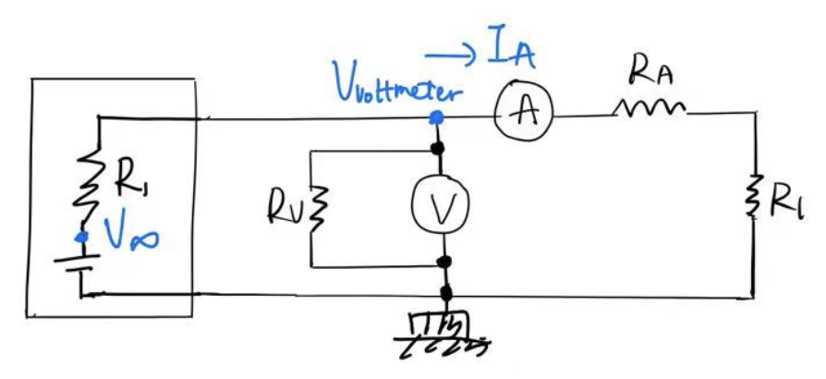
Applying Nodal Analysis on the entire circuit gives:
$$\frac{V_{∞}-V_{voltmeter}}{R_{1}}=\frac{V_{voltmeter}}{R_{V}}+I_{A}$$
Re-arranging gives:
$$V_{voltmeter}=\frac{\frac{V_{∞}}{R_{1}}-I_{A}}{\frac{1}{R_{V}}+\frac{1}{R_{1}}}$$
Taking the derivative of $V$ in terms of $I_{3}$ gives:
$$\frac{dV}{dI_{A}}=\frac{-R_{V}R_{1}}{R_{V}+R_{1}}=m_{1}$$
Re-arranging gives:
$$R_{1}=\frac{{-R}_{V}m_{1}}{R_{V}+m_{1}}$$
$R_{1}= \frac{-65790859.3*(-0.04612)}{65790859.3+(-0.04612)}$ = 0.04612
To find the uncertainty of R1, take the partial derivative of the equation:
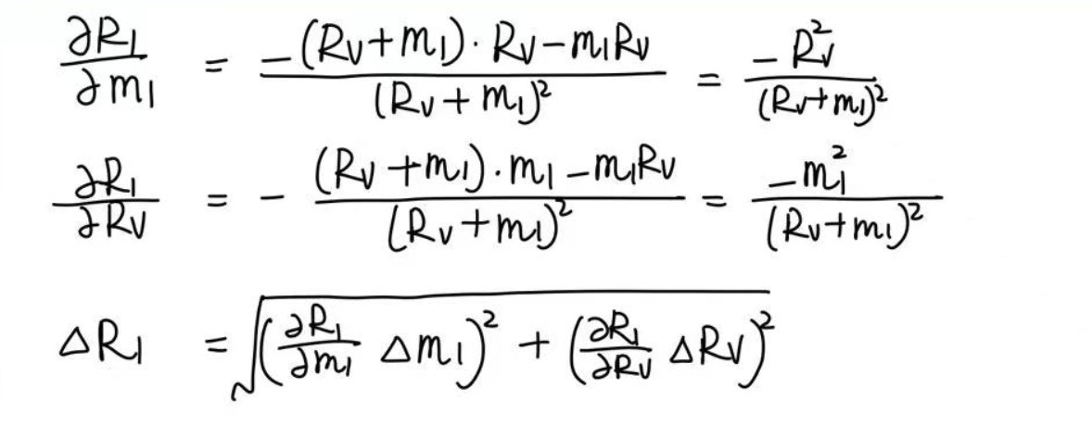
Plug in values calculated from Part II for each $R_{l}$, and take the average to get
$∆R_{1}$ = 0.00896

- Derive a relationship among $m_{2}$, $R_{A}$ and $R_{2}$ to find the output resistance with its uncertainty. Show the steps of your error propagation calculation for the uncertainty of $R_{2}$.

Applying Nodal Analysis across $V_{∞}$ and $V_{voltmeter}$ gives

$$I_{total}=\frac{{V_{∞}-V}_{voltmeter}}{R_{2}+R_{A}}$$
Re-arranging gives:
$$V_{voltmeter}=V_{2}-I_{total}*(R_{2}+R_{A})$$
Taking the derivative of $V$ in terms of $I_{total}$ gives:
$$\frac{dV}{dI_{total}}=-\left(R_{2}+R_{A}\right)=m_{2}$$
$$R_{2}=-R_{A}-m_{2}$$
$R_{2}$ = -0.5178 - (-0.04613) = -0.4717
To find the uncertainty of R2, take the partial derivative of the equation:
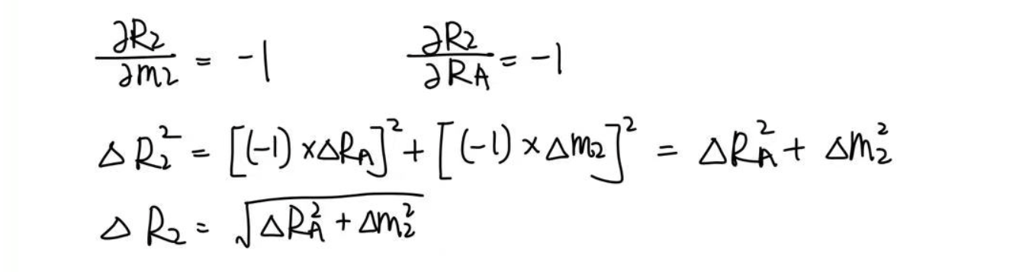
Plug in values calculated from Part II for each $R_{l}$, and take the average to get
$∆R_{2}$ = 1.5683

- Show the output resistance of the battery (or DC power supply) as: $R_{1}$ = (0.04612 ± 0.00896) Ω and $R_{2}$ = ( -0.4717 ± 1.5683 ) Ω.
- Write a brief conclusion on the difference between the two results.
If assuming both the voltmeter and the ammeter are ideal, the power output’s internal resistance $R$ is just going to be $\frac{{V_{∞}-V}_{voltmeter}}{R_{A}}$ by Nodal Analysis. However, in Option 1, current flows through $R$ is more than the value measured by the ammeter, so $R_{A}$ is smaller than expected, producing a larger resistance $R_{1}$. In Option 2, the non-ideal ammeter generates some amount of voltage, so the voltmeter measures the sum of output voltage and ammeter voltage, making $V_{voltmeter}$ larger than expected and resulting in a smaller $R_{2}.$

Work Cited
[R^2] https://blog.minitab.com/en/adventures-in-statistics-2/regression-analysis-how-do-i-interpret-r-squared-and-assess-the-goodness-of-fit

